Culture Monster

Art Review: "Until We Come to One that Reminds Us" at Monte Vista Projects
August 19, 2009

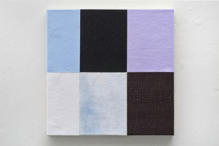
“Until We Come to One That Reminds Us,” a modest but canny group show at Monte Vista Projects speaks to a question that has begun to nag at the conscience over the course of the last year: what relation all the stuff that fills our galleries (that is, art) bears or should bear to all the stuff going on outside (war, political unrest, financial turmoil, widespread unemployment, hardship).
In presenting, as the press release puts it, "four artists whose works reflect an engagement with materials in a landscape of personal and political trouble," the show underscores the degree to which a sense of conscience (political, social, emotional or otherwise) can imbue not only the concepts but the very material substance of a work.
Curt LeMieux’s two wall-mounted sculptures, “Gardener’s Glove” and “Book Cover,” are perhaps the most striking examples: compact assemblages of wood, nails, foam, bits of canvas and other detritus, all painted a rich, glossy black — with the exception of a bright orange book cover that’s bound to one of them — that somehow evoke a distinct impression of power, violence and dangerous elegance.
A pair of untitled works by Amy Green — canvases covered in squares of multicolored felt — are gentler but similarly resonant abstractions. Christine Frerichs’ three canvases play with painterly motifs, most poignantly in “Girl,” a small piece in which the eponymous figure appears as a vaporous smudge.
The show’s centerpiece is Kristina Faragher’s “Thirty-Six of Them,” a wall-mounted assortment of small, rectangular balsa wood boxes, all coated in candy-colored enamel and appearing in various states of collapse. Like LeMieux’s pieces, they make no explicit references but call to mind a community of bombed buildings, arousing a sense of both tragedy and grandeur.
Monte Vista Projects, 5442 Monte Vista St., Los Angeles through Sept. 5. Closed Mondays through Fridays. www.montevistaprojects.com
--Holly Myers
Above: Untitled work by Amy Green. Photo credit: Courtesy of Monte Vista Projects

